Form Handling

1.

Create an HTML form as

shown in the picture

2.

Create a PHP script that

will accept and display

the data filled from the

form

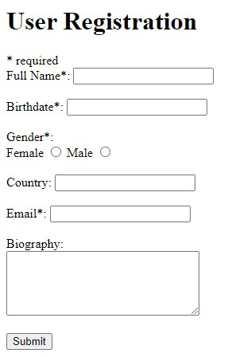

1. Perform server side validation for the aBove form following the rules listed below.

|  |  |
| --- | --- |
| **Field** | **Validation Rules** |
| Full Name | Required. + Must only contain letters and whitespace |
| E-mail | Required. + Must contain a valid email address (with @ and .) |
| Birthdate | Required. + Must only be above 18 |
| Biography | Optional. Multi-line input field (textarea) |
| Gender | Required. Must select one |
| Country | Optional. + Must only contain letters and whitespace |